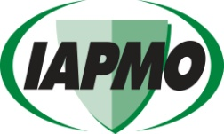
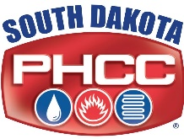
Registration Form
2026 South Dakota Continuing Education for
Plumbing Contractors, Journeymen & Apprentices

Approved by the SD State Plumbing Commission to fulfill the requirements needed for license renewal

ONLINE PRE-REGISTRATION IS ENCOURAGED. FAST, EASY AND AUTOMATIC CONFIRMATION.
To secure your seat, register online any time at www.iapmo.org/SD
Online registration payment options available: Electronic-check or credit card

Registration Deadline: 2 days prior to the selected class date
Each attendee must complete a registration – photo copy this form as needed.

Please PRINT clearly

Class Location:______________________________________________________________________Class Date:_________________________________

First Name Last Name Middle Initial__________

Mailing Address

City State Zip Code

*Phone *Email Address___________________________________________________________________

*South Dakota Plumbing License Number _______________________________________________________________________________________

Iowa Plumbing License Number (if you hold an Iowa License)___________________________________________________________________

*Required: Phone & email information is needed to contact you with questions regarding your registration or class notifications.

METHOD OF PAYMENT
Register online at www.iapmo.org/SD • Registration Fee: $80.00 • Class Time: 6:00pm to 9:45pm

[ ] MasterCard | [ ] Visa | [ ] American Express |  |  | [ ] Money Order/Check
Email Form and payment to:  seminars@iapmo.org |  |  |  | Mail money order/check payable to IAPMO to:  IAPMO, 18927 Hickory Creek Dr, Suite 220, Mokena, IL 60448

Credit Card Number Expiration Date CVV

Name on Credit Card Signature

Billing address for credit card __________________________________________________________________________________________________

_________________________________________________________________________________________________________________________________

Registration Customer Service:
IAPMO Training & Education Department
18927 Hickory Creek Drive, Suite 220 • Mokena, IL 60448
Phone: 708-995-3000 • E-mail: seminars@iapmo.org • Website: www.iapmo.org/SD

